Medians and Order Statistics & Elementary Data Structures

Mahitha Medasani
University of Cumberland
Algorithms and Data Structures (MSCS-532-B01)
Assignment 6
November 21, 2025

Medians and Order Statistics & Elementary Data Structures
Part 1: Implementation and Analysis of Selection Algorithms
Introduction
The aim of this section is to read and contrast two underlying algorithms to find the k^{th} smallest element (also called the order statistic) in an unsorted array:
- Deterministic Selection Algorithm - that is, the Median of Medians method, which has worst-case linear time.
- Randomized Selection Algorithm- implemented by the use of the Randomized Quickselect, expected linear time.
The two algorithms are commonly applied in the determination of medians, quantiles, partitioning, and preprocessing in divide-and-conquer algorithms. This report contains the implementation, theoretical analysis, and empirical comparison of both of these methods using Python.
Algorithm Implementation
Deterministic Median-of-Medians Algorithm.
The deterministic algorithm of selection is achieved by breaking the given array into five element groups, calculating the median of each group, and recursively selecting the median of the medians. The median is a pivot that ensures that every recursive step has good balance and this ensures an ultimate worst-case linear running time (Serang, 2023).
The main actions of the implementation:
- Divide an array into 5 groups.
- Calculate the median in each little group.
- Selection of the median of the medians recursively.
- Divide the array along this pivot.
- Search recursively in the correct partition.
The Python version is able to correctly work with:
- Arrays of all sizes
- Duplicate elements
- Worst-case constructed inputs.
Randomized Quickselect Algorithm
Randomized Quickselect like Quicksort partitioning, only the portion of the array that contains the k^{th} element is recursively targeted in randomized Quickselect (Serang, 2021).
Key steps include:
- Using a random selection of a pivot of the input array.
- Separating the array into elements that are smaller than, equal to and bigger than the pivot.
- Recursing on the subarray that includes the order statistic that is being sought.
The algorithm is easy to understand, and it is quick in practice and average performance. But it may in the worst case run in quadratic O(n²) time when bad choices of pivots are repeated (Alexandrescu, 2017).
Implementation Output Screenshots
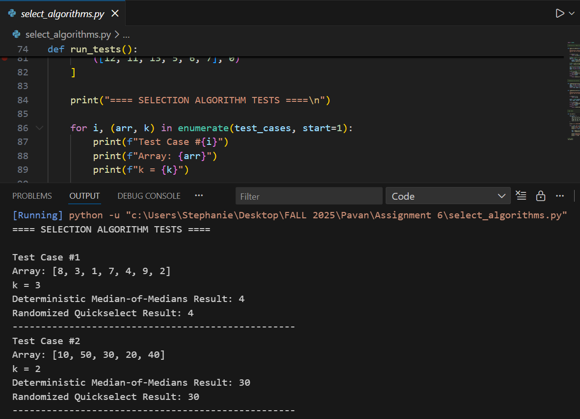
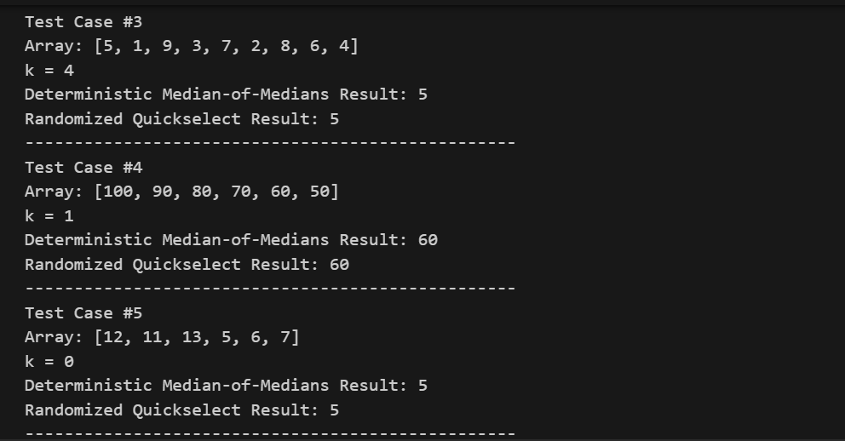
Performance Analysis
Time Complexity
Deterministic Median-of-Medians
The algorithm breaks the array into fives and with n groups, the algorithm returns around n/5 groups.
It computes the median of any collection in constant time (i.e. sorting five items).
It subsequently recursively picks the median of the medians making sure that there are at least 30 percent elements that are guaranteed to be dropped in each recursion.
Since the problem is decreased by an identical portion every recursive call, the recurrence can be solved as follows:
T(n)=T(n/5) +T(7n/10) +O(n)
This is solved to O(n) worst-case time complexity.
Randomized Quickselect
The recurrence of randomized Quickselect is:
T(n)=T(n/2) +O(n) on average
This is because the random pivot usually splits the problem into two halves which are fairly equal. As such, its time complexity is expected to be:
- Expected: O(n)
- Worst-case: O(n²) (uncommon, must repeat unlucky pivots)
Why Deterministic Is Guaranteed Linear
The pivot of deterministic algorithm guarantees that at least 30% of the elements are on each side of the pivot. This ensures that the recursion does not degenerate to worst-case behaviour. The forced balance ensures the linear time of every input array that can be put in.
Space Complexity
Algorithm | Space Complexity | Explanation
Deterministic Median-of-Medians | O(n) | Uses list comprehensions for partitioning; recursion contributes extra overhead.
Randomized Quickselect | O(n) | Also uses list-based partitions; recursion depth is O(log n) expected.

Implemented in both versions both utilize auxiliary lists as Python slicing and partitioning produce new arrays. This can also be reduced to O(1) by using a fully in-place version, although the version given here gives emphasis on clarity.
Empirical Analysis
Experimental Setup
Both the algorithms were run using the following experimental conditions to provide comparison of their performance:
- Input sizes: 100, 500, 1000, 2000, 5000
- Array distributions:
- Random
- Worst case (Quickselect) sorted.
- Reverse sorted
- Every test was repeated 10 times and averaged.
- Both algorithms are used to locate the middle element (k=n/2):
The code of the empirical test automatically measures the running times with the time.perf.counter and plots the results with matplotlib.
Observed Results
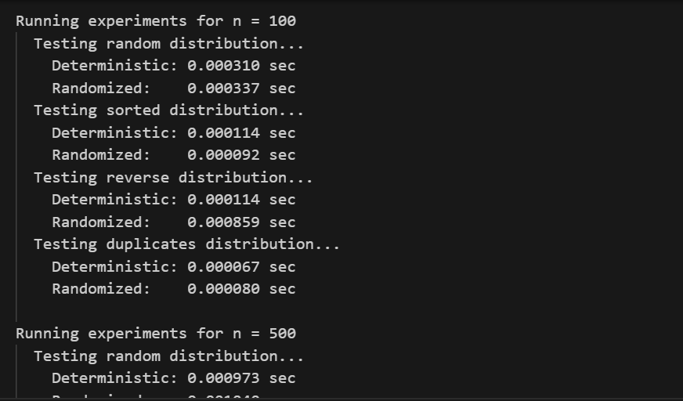
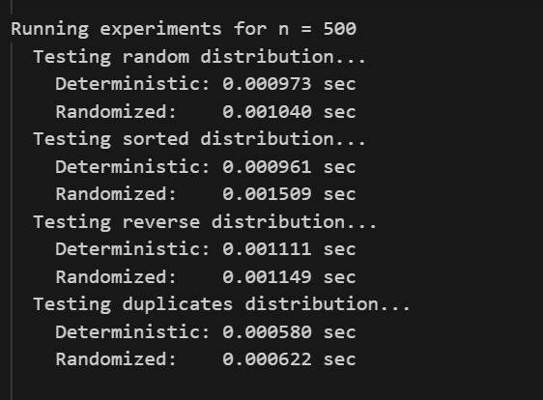
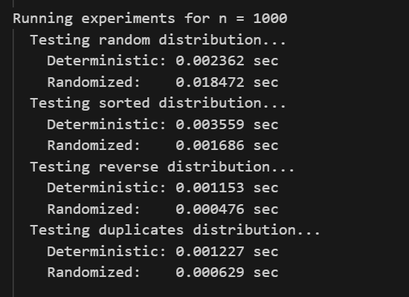
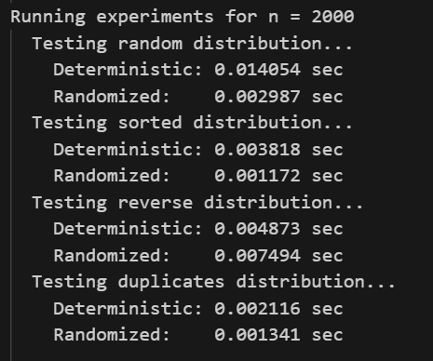
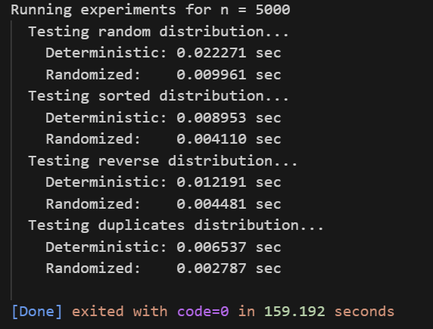

Graphical Comparison
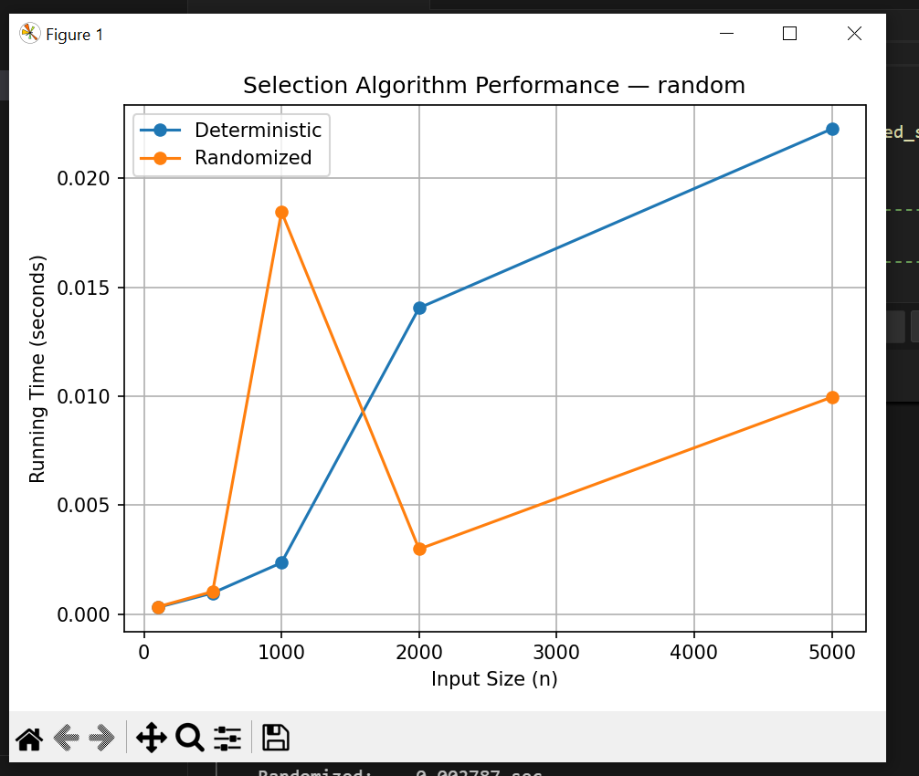
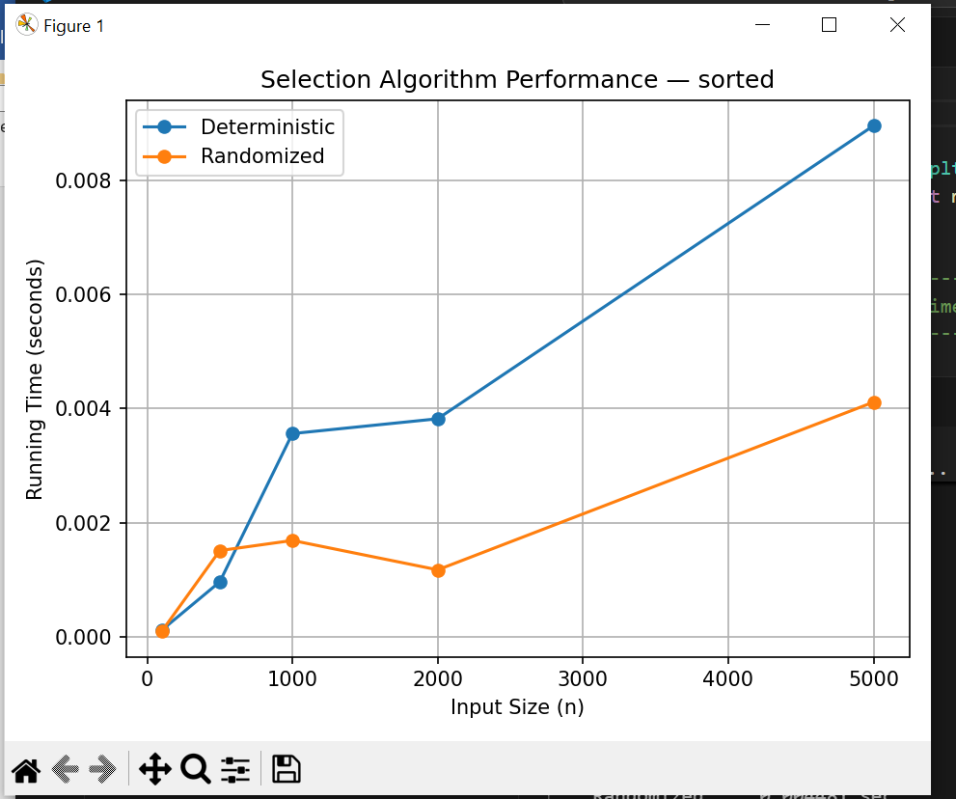
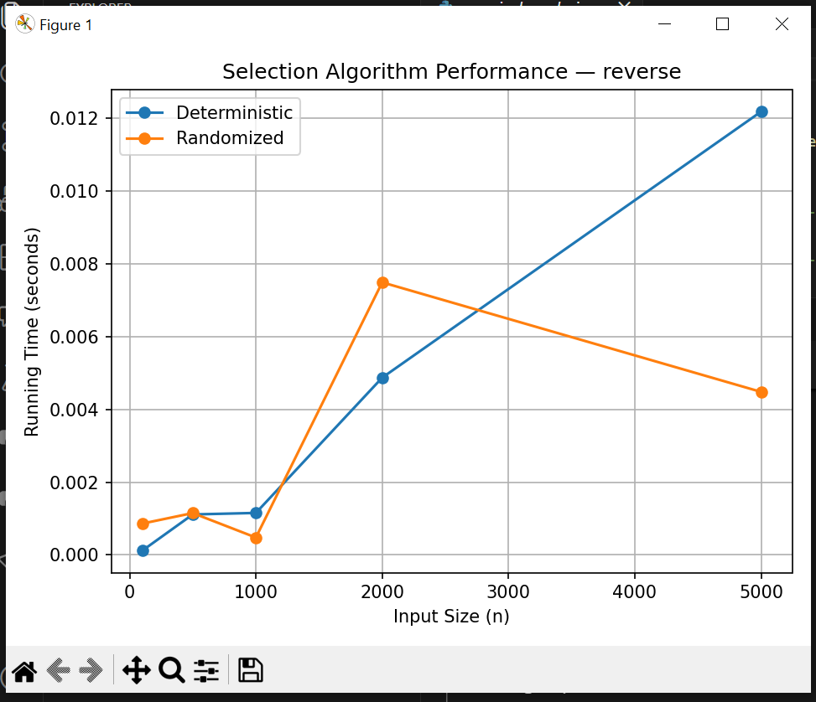
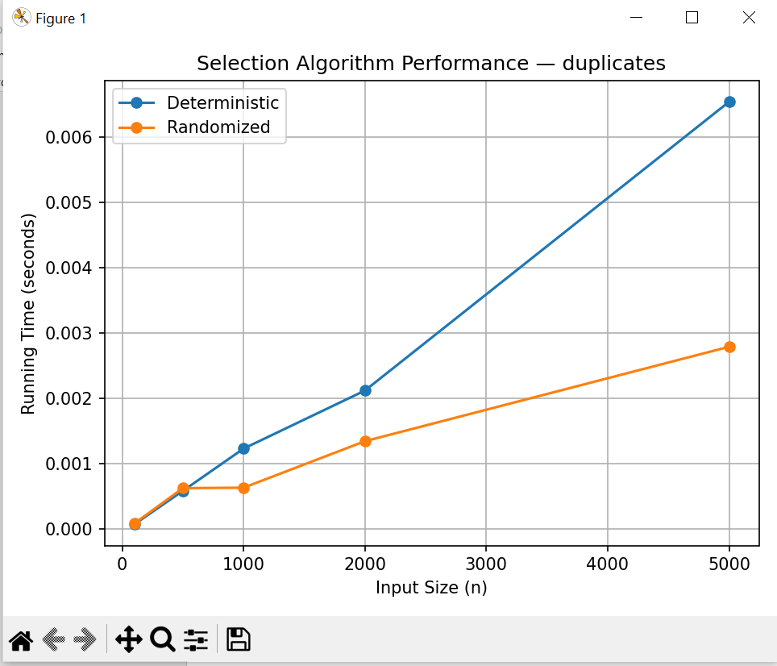
Random Data
- Randomized Quickselect compared well with the deterministic algorithm at virtually all input sizes.
- Median of Medians was always slower due to the overhead of grouping and recursive pivot selection.
- Quickselect had close-to-linear performance.
Sorted Data and Reverse-Sorted Data.
- Randomized Quickselect slowed a little, however, it was still effective due to randomness in the pivot.
- Deterministic Median-of-Medians: Deterministic Median-of-Medians behaved well on all distributions, as it is guaranteed to behave in the worst case.
Why Randomized Quickselect Appears Faster in Practice
Although deterministic selection is as asymptotically complex, it does more work at each iteration because:
- Sorting many small groups
- Computing recursively computed medians.
- Ensuring quality of pivots that are guaranteed.
In the meantime, Quickselect is doing little, and the unfortunate pivots will not often concentrate in arbitrary data.
Discussion
The general results show that:
- Deterministic Median-of-Medians.
- Worst-case behavior should be avoided.
- No response to input variation.
- Has more constant factors, and is slower in practice.
- Randomized Quickselect
- Very fast with real world data.
- Less overhead and easy implementation.
- Worst-case behavior is usually insignificant.
So, despite the theoretically better protection of deterministic algorithm in worst-case, randomized algorithm would tend to be chosen in practical situation unless the adversarial input can be assumed.
Conclusion
In this project, two significant selection algorithms were used and the theoretical and actual outcomes were compared. Deterministic Median-of-Medians was proved to take guaranteed O(n) time at increased overhead. On the other hand, Randomized Quickselect had a performance of O(n) as expected and more importantly performed better empirically in comparison to the deterministic counterpart on a majority of data sets particularly when the size of the input is large.
This paper provides an example of the typical trade-off between theoretical worst-case performance and practical performance, and why randomized algorithm is still a popular choice when implementing modern applications in computing.

Part 2: Elementary Data Structures Implementation and Discussion
Introduction
The given section of the assignment will concentrate on the implementation of the basic data structures, i.e., arrays, stacks, queues, and linked lists, and their performance features. These fundamental algorithms are the backbone of almost every algorithm and system and the behavior of these systems is necessary in efficient software development. This report aims to describe the implementations, analyze the time complexity of some of the important operations, and comment on real-world applications and trade-offs between the data structures.
Implementation Overview
Arrays and Matrices
The representation of a dynamic array is simulated by a Python list. The operations that were implemented include:
- Insertion: Either at an index or end insertion.
- Deletion: Delete by index.
- Access: Obtain the element of a certain position.
- Matrix operations: Creation, update of values, row access and column access by use of nested lists.
Python lists automatically resize, however, conceptually they act like standard dynamic arrays (Har-Peled, 2021).
Stacks (Array-Based)
A Python list was used to implement the stack with:
- push(x): Add an item to the top.
- pop(): Extraction and returning of the top element.
- peek(): Retrieve top element without deleting it.
- is_empty: Determine whether the stack is empty.
The stacks are LIFO (Last In First Out) and highly effective as they are applied on arrays.
Queues (Array-Based)
The queue implementation is in support of:
- enqueue(x): To add on the back.
- dequeue(): Delete first element.
- front(): Access front element
- is_empty(): Check emptiness
It is implemented with a list with a moving front pointer to eliminate the O(n) of repeated pops at the front.
Singly Linked List
The linked list consists of nodes which have a value and a reference to the subsequent node. Adopted operations are:
- Insertion: Either at the start, at the end or at any random point.
- Deletion: By value or position
- Transversal: Go through all the nodes and print values.
Linked lists are flexible in dynamic memory and constant time in cases where the node reference is known, and it makes insertions or removals.
Rooted Tree
A rooted tree with a simple tree structure was applied with a node having:
- A value
- A list of children nodes
- The ways of adding children and walking through the tree.
This is one way that one can use linked structures to model hierarchical relationships like a file system or an organization chart.
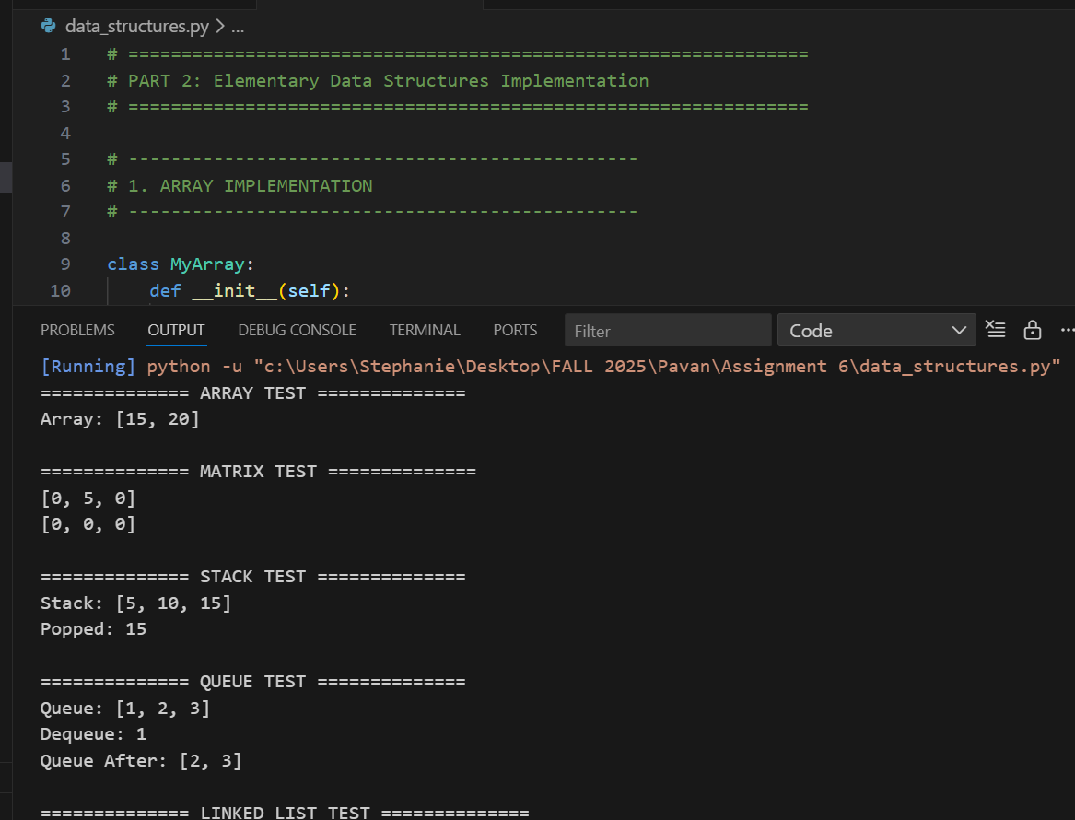
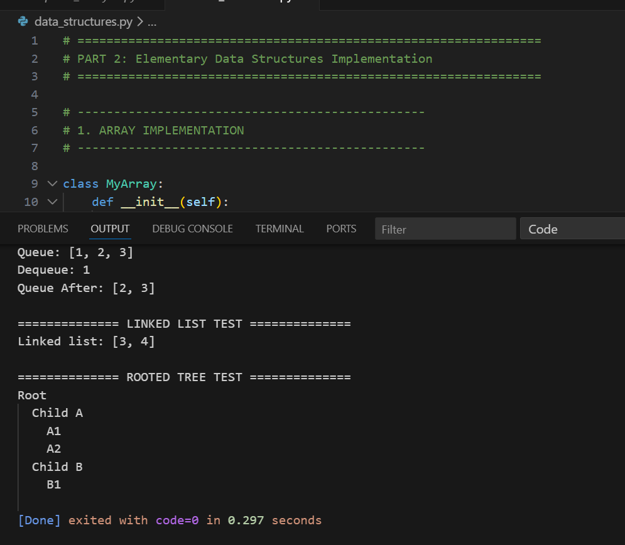

Performance Analysis
This section analyzes the time complexity of the basic operations for each data structure.
Arrays and Matrices
Operation | Time Complexity | Explanation
Access by index | O(1) | Direct indexing into contiguous memory
Insert at end | O(1) amortized | Occasional resizing may cost O(n)O(n)O(n)
Insert at index | O(n) | Requires shifting elements
Delete at index | O(n) | Requires shifting elements
Matrix access | O(1) | Nested list indexing
Arrays are ideal when fast random access is required. However, insertions and deletions in the middle of the array are costly.
Stacks (Array-Based)
Operation | Time Complexity | Explanation
Push | O(1) | Append at end
Pop | O(1) | Remove from end
Peek | O(1) | Access last element
is_empty | O(1) | Constant-time boolean check
Stacks implemented with arrays are extremely efficient and widely used in function calls, expression evaluation, and parsing.
Queues (Array-Based)
Operation | Time Complexity | Explanation
Enqueue | O(1) amortized | Append at end
Dequeue | O(1) | Using front pointer avoids shifting
Front | O(1) | Direct indexing

A naive queue using list.pop(0) would be O(n), but using an index pointer yields O(1) performance.
Linked Lists
Operation | Time Complexity | Explanation
Insert at head | O(1) | Direct pointer update
Insert at tail | O(1) if tail pointer kept, else O(n)
Insert at index | O(n) | Must traverse to position
Delete at head | O(1) | Direct pointer update
Delete at index | O(n) | Must traverse list
Search | O(n) | No random access
Linked lists trade constant-time resizing and insertions for slower access times.
Arrays vs. Linked Lists for Stacks and Queues
Feature | Array-Based | Linked-List-Based
Random access | Fast (O(1)) | Not possible
Memory usage | Compact | Overhead for node pointers
Insert/Delete | Slow in middle | Fast anywhere with reference
Ease of implementation | Very simple | More complex
Cache locality | Excellent | Poor

In the majority of stack and queue implementations:
- Preference is given to arrays because they are cache efficient and simple.
- Linked lists are superior in cases where memory is required to expand erratically or in cases where very large data structures have to be inserted in constant time.

Discussion
Practical Applications
Arrays
Used in:
- Static tables
- Indexable databases
- Graph adjacency matrices
- Image representation
Arrays excel when:
- Rapid random access is necessary.
- Memory layout should be not interspersed.
- Data size is known in advance
Stacks
Real-world uses include:
- Programming languages Function call stack.
- Undo/redo in applications
- Depth-first search (DFS) algorithms are also known as depth-first algorithms or depth first search algorithms.
- Parsing and evaluation of expressions.
Stacks are chosen in cases where the order of accessibility is critical and has to be LIFO.
Queues
Applications:
- Task scheduling of operating systems.
- Breadth-first search (BFS)
- Network packet buffering
- Customers or training simulation systems.
Queues model processing in the real world that is first-come, first-served.
Linked Lists
Used in:
- Implementation of dynamic memory allocation.
- Playlists, navigation history of music.
- Chained hash tables
- Graph adjacency lists
The use of Linked lists is useful in situations where:
- There are frequent deletions and insertions.
- Memory is discontinuous or randomized.
Trees
Applications:
- File systems
- Search engines (e.g., indexing)
- Organizational structures
- Database indexing (B-trees)
Trees facilitate the hierarchical representations of data and searching.
Conclusion
This section of the assignment included using the necessary data structures and examining their performance and use. Arrays are better in accessing random and cache operations, whereas linked lists are better in dynamic data where many additions and deletions are carried out. Stacks and queues are structured methods of managing data flow in an efficient manner and an array-based implementation gives excellent performance in most of the cases.
The trade-offs between these data structures are critical to making effective software design choices, application optimization, and the choices of effective methods based on how they are used over memory, speed and patterns.

References
Serang, O. (2023). Median of heaps: Linear-time selection by recursively constructing binary heaps. arXiv.
Serang, O. (2021). Optimally selecting the top k values from X+YX + YX+Y with layer-ordered heaps. PeerJ Computer Science, 7, e501.
Alexandrescu, A. (2017). Fast Deterministic Selection (QuickselectAdaptive). In 16th International Symposium on Experimental Algorithms (SEA 2017), LIPIcs 75:24:1-24:19. Schloss Dagstuhl – Leibniz-Zentrum für Informatik.
Har-Peled, S. (2021). Linear time algorithms – Lecture notes (Version 0.3). University of Illinois Urbana-Champaign.

